SIMATS ENGINEERING (SAVEETHA SCHOOL OF ENGINEERING)
Department of Computer Science and Engineering
CO1 ASSESSMENT TOOL 2 – Agile Sprint Planning & User Story Workshop
Course Code: | CSA10 / CSA1004 | Course Title: | Software Engineering
CO Assessed: | CO1 | Assessment: | Assessment Tool 2 – Agile Sprint Planning & User Story Workshop
Weightage: | 20% | Total Marks: | 25
CO1 Statement: | Apply advanced methodologies and agile project management techniques to manage software projects effectively
Student Name: | Pradhap J | Reg. No.: | 1924260246
Date: | 14/10/2026 | Duration: | 60 minutes

Code of Conduct
I, Pradhap J (Reg. No. 1924260246), certify that this submission is my original work and that I have adhered to the guidelines specified for this assessment. I understand that any violation of academic integrity rules will result in disciplinary action.
Signature of the Student: _________________________
Annexure A – Agile Sprint Planning & User Story Workshop
Instructions to Students:
Each student is assigned an individual software project problem statement. Based on the given problem statement, perform an Agile Sprint Planning and User Story Workshop by applying Agile software engineering practices. Prepare a comprehensive sprint planning document covering the following aspects:
- Identify the Project Vision and Stakeholders – Define the project’s vision, objectives, and identify all key stakeholders involved.
- Create Epics and User Stories – Break down the requirements into Epics and formulate well-structured User Stories using the format: As a <user>, I want <feature>, so that <benefit>.
- Define Acceptance Criteria – Write clear and measurable acceptance criteria for each selected user story using the Given–When–Then format or equivalent.
- Prioritize the Product Backlog – Organize and prioritize the product backlog based on business value, customer needs, and project dependencies.
- Plan the Sprint Backlog – Select high-priority user stories for the first sprint and divide them into actionable development tasks.
- Estimate Effort Using Story Points – Assign story points to each selected user story using an appropriate estimation technique (e.g., Fibonacci sequence or Planning Poker) and justify your estimates.
- Present the Sprint Goal and Expected Deliverables – Define a clear sprint goal and describe the expected sprint deliverables, including the features to be completed at the end of the sprint.
PROJECT: INTELLIGENT PERSONAL FINANCE MANAGEMENT SYSTEM
Agile Sprint Planning & User Story Workshop
1. Project Vision and Stakeholders
Project Vision: To develop a secure, easy-to-use personal finance application that helps users record income and expenses, organize transactions by category, set budgets, monitor savings goals, and understand their spending through clear summaries and alerts. The system aims to support informed financial decisions while keeping personal financial data private.
Objectives:
- Record and categorize income and expenses in one place.
- Show monthly spending, income, balance, and category-wise summaries.
- Allow users to set budgets and receive alerts when spending approaches a limit.
- Help users define savings goals and track progress.
- Protect account access and financial information through authentication and privacy controls.

Stakeholder | Role / Interest
End user | Records transactions, reviews reports, manages budgets and savings goals.
Project owner / Product owner | Defines product scope, prioritizes features, and accepts completed stories.
Development team | Designs, builds, integrates, and maintains the application.
UI/UX designer | Creates simple navigation, accessible forms, and readable dashboards.
QA / Test engineer | Tests calculations, validation, usability, security, and acceptance criteria.
System administrator | Manages deployment, backups, access controls, and system reliability.
2. Epics and User Stories
Epic | ID | User story | Priority
Account and security | US-01 | As a user, I want to register and sign in securely, so that my financial information is protected. | Must have
Transaction management | US-02 | As a user, I want to add income and expense transactions, so that I can maintain an accurate record of my money. | Must have
Transaction management | US-03 | As a user, I want to edit or delete a transaction, so that I can correct entry mistakes. | Should have
Categories and reports | US-04 | As a user, I want transactions grouped by category, so that I can understand where my money goes. | Must have
Budget management | US-05 | As a user, I want to set a monthly budget for a category, so that I can control my spending. | Should have
Budget management | US-06 | As a user, I want to receive an alert when I approach or exceed a budget, so that I can adjust my spending. | Should have
Savings goals | US-07 | As a user, I want to create a savings goal and track contributions, so that I can measure progress toward a target. | Could have
Dashboard | US-08 | As a user, I want to view a monthly summary of income, expenses, and balance, so that I can make informed decisions. | Must have
3. Acceptance Criteria
Story | Given – When – Then acceptance criteria
US-01 – Sign in | Given a registered user, when valid credentials are submitted, then the system opens the user dashboard. Given invalid credentials, when sign-in is attempted, then access is denied and a clear error message is shown.
US-02 – Add transaction | Given the user is signed in, when a valid amount, transaction type, date, and category are entered and saved, then the transaction appears in the transaction list and the totals update. Invalid or missing required fields must be rejected with a message.
US-03 – Edit/delete | Given an existing transaction, when the user edits and saves it, then the updated values appear in the list and summaries. When deletion is requested, the system asks for confirmation before removing it.
US-04 – Categories | Given transactions with categories, when the user opens the category report, then each category shows its calculated total for the selected period and the totals match the underlying transactions.
US-05 – Set budget | Given a selected month and category, when the user saves a positive budget amount, then the budget is stored and the dashboard displays spent amount and remaining budget.
US-06 – Budget alert | Given a budget exists, when spending reaches the configured warning threshold or exceeds the limit, then the application displays an alert identifying the category and current spending.
US-07 – Savings goal | Given a goal name and target amount, when the user saves the goal and records a contribution, then the goal progress and remaining amount are recalculated.
US-08 – Monthly summary | Given income and expense transactions for a selected month, when the dashboard loads, then it displays total income, total expenses, and balance (income minus expenses) accurately.
4. Prioritized Product Backlog
The backlog is prioritized using MoSCoW (Must, Should, Could) based on user value, dependencies, and the minimum usable product. Authentication and transaction recording are prioritized because reports and budgets depend on reliable transaction data.
Rank | Story / Feature | Priority | Reason
1 | US-01: Registration and sign-in | Must | Protects private data and establishes user access.
2 | US-02: Add income/expense | Must | Core feature; supplies data for all calculations.
3 | US-08: Monthly dashboard summary | Must | Provides immediate value and validates financial totals.
4 | US-04: Category reports | Must | Enables users to understand spending patterns.
5 | US-03: Edit/delete transactions | Should | Needed to correct mistakes and maintain accuracy.
6 | US-05: Monthly budgets | Should | Adds spending control after transactions are available.
7 | US-06: Budget alerts | Should | Depends on budget setup and spending calculations.
8 | US-07: Savings goals | Could | Useful enhancement after the core finance workflow works.
5. Sprint Backlog – Sprint 1
Sprint duration: 2 weeks. Sprint 1 focuses on a working foundation: secure sign-in, recording transactions, and a basic monthly summary. The selected stories are US-01, US-02, and the basic portion of US-08.
User story / Task | Actionable development task | Owner role | Estimate
US-01 | Design registration/sign-in screen and validation rules. | UI/UX + Developer
US-01 | Implement authentication flow and protected dashboard access. | Developer
US-01 | Test valid/invalid login and access restrictions. | QA
US-02 | Design transaction form with type, amount, date, category, and note. | UI/UX + Developer
US-02 | Implement save/list functionality and required-field validation. | Developer
US-02 | Verify income/expense records and persistence. | Developer + QA
US-08 | Calculate monthly income, expenses, and balance from saved transactions. | Developer
US-08 | Display totals on the dashboard and test sample calculations. | Developer + QA
All selected stories | Conduct integration testing, fix defects, and demonstrate the sprint increment. | Whole team
6. Story Point Estimation and Justification
Planning Poker with Fibonacci values (1, 2, 3, 5, 8, 13) is used. Estimates reflect complexity, uncertainty, and testing effort; they are relative effort points, not hours.
Story | Points | Justification
US-01 – Registration/sign-in | 5 | Moderate effort: form validation, authentication flow, access protection, and negative testing.
US-02 – Add transaction | 5 | Moderate effort: transaction form, validation, saving, listing, and data checks.
US-08 – Monthly summary | 3 | Lower effort once transaction data is available; requires accurate aggregation and display.
US-03 – Edit/delete | 3 | Standard update/delete operations with confirmation and recalculation.
US-04 – Category reports | 5 | Requires grouping, filtering by period, and validating totals.
US-05 – Budget setup | 5 | Requires monthly/category budget records and remaining-budget calculation.
US-06 – Alerts | 3 | Threshold checking and user-facing alert behavior; depends on budgets.
US-07 – Savings goals | 5 | Goal data, contribution tracking, and progress calculations.
Sprint 1 commitment: US-01 (5) + US-02 (5) + US-08 basic summary (3) = 13 story points. This is a provisional commitment for a small team and should be adjusted using the team’s actual capacity and previous velocity.
7. Sprint Goal and Expected Deliverables
Sprint Goal: Enable a user to securely access the Intelligent Personal Finance Management System, record income and expenses, and view a correct monthly financial summary.
Expected deliverables at the end of Sprint 1:
- A basic registration/sign-in workflow with validation and protected access.
- A transaction form and list for income and expenses with required-field checks.
- A dashboard showing monthly income, expenses, and balance calculated from stored transactions.
- Test cases and test results for authentication, transaction validation, and summary calculations.
- A sprint review demonstration and an updated product backlog containing feedback and remaining work.
Definition of Done: Code is integrated; acceptance criteria pass; calculations are checked using sample data; no critical defects remain; and the increment is demonstrated to the product owner.
Jira Sprint Board Screenshot
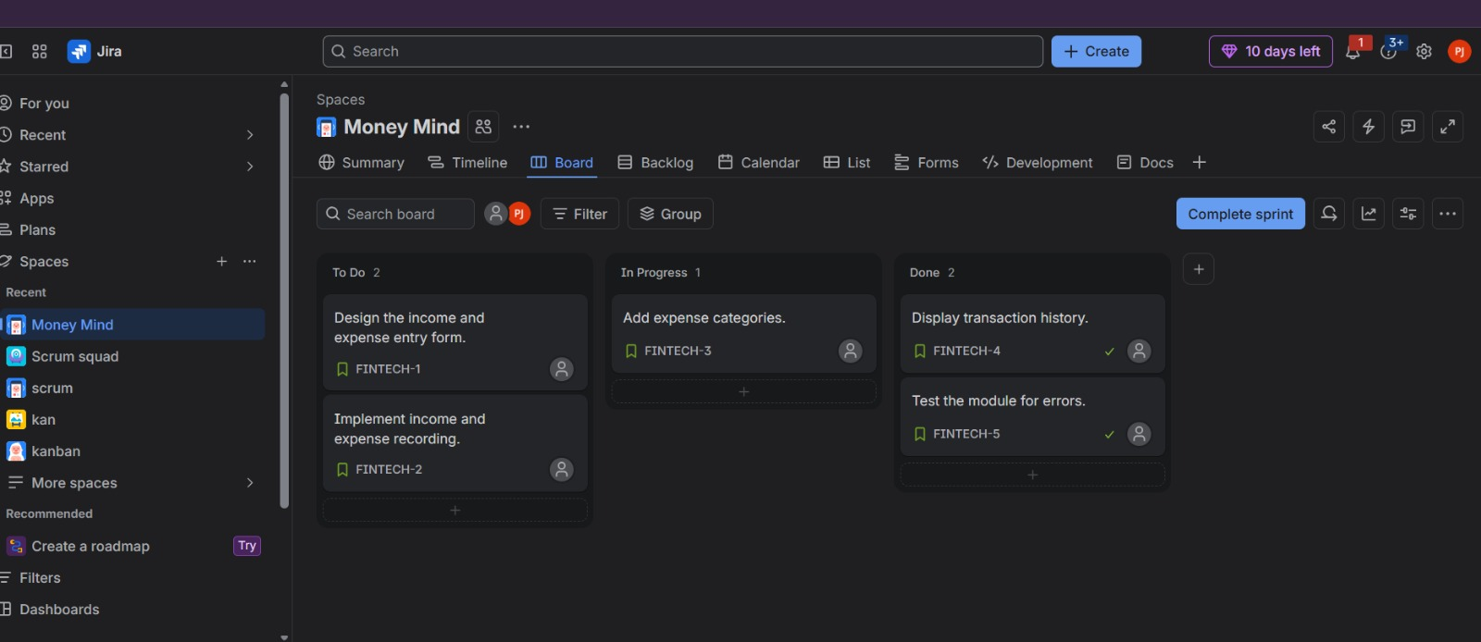
Figure 1: Jira board (Money Mind) showing Sprint 1 tasks across To Do, In Progress and Done.

